Senior Booklist:
If you like:
History/Geography/Politics:
- All the Light We Cannot See by Anthony Doerr
- American Dirt by Jeanine Cummins
- 1984 by George Orwell – A modern classic about the idea of government control and how ‘free’ we really are. See also ‘Animal Farm’ (which is shorter)
- Sozaboy by Ken Saro Wiwa – This book is a challenge, as it is written in West African Pidgin English, but is worth the effort as is an incredible insight into war from the inside.
- Restless Souls by Dan Sheehan – An outstanding story of male friendship – with three Dublin friends going on a roadtrip across America to help their friend who has recently returned from the war in Sarajevo. Very funny and insightful.
- The Kite Runner by Khaled Hosseini (see also “And so the Mountains Echoed”)
- The Vanishing Half by Brit Bennett
  - The Vignes twin sisters will always be identical. But after growing up together in a small, southern black community and running away at age sixteen, it's not just the shape of their daily lives that is different as adults, it's everything: their families, their communities, their racial identities. Many years later, one sister lives with her black daughter in the same southern town she once tried to escape. The other passes for white, and her white husband knows nothing of her past. Still, even separated by so many miles and just as many lies, the fates of the twins remain intertwined. What will happen to the next generation, when their own daughters' storylines intersect?
Psychology/Drama/Human relationships (inc. comedy!):
- Americanah by Chimamanda Ngozi Adiche - An insightful and engaging novel about the reality of race relations in America today (see also her books ‘Purple Hibiscus’ and ‘Half of a Yellow Sun’)
- We Are All Completely Beside Ourselves by Karen Joy Fowler
  - Meet the Cooke family. Our narrator is Rosemary Cooke. As a child, she never stopped talking; now that she's started college, she has wrapped herself in silence: the silence of intentional forgetting, of protective cover. Rosemary is now an only child, but she used to have a sister the same age as her, and an older brother. Both are now gone—vanished from her life. Her once lively mother is a shell of her former self, her clever and imperious father now a distant, brooding man. And there was something unique about Rosemary's sister, Fern.
You'll have to find out for yourself what it is that makes her unhappy family unlike any other.
- The Poisonwood Bible by Barbara Kingsolver – another author with a number of excellent novels, this story of an American missionary family trapped in the Congo is a real page turner. (see also her books “Flight Behaviour” and “The Lacuna”
- Novels by Zadie Smith: Swing Time, White Teeth and On Beauty are all excellent
- Where the Crawdads Sing by Delia Owens
- Educated by Tara Westover
  - Our protagonist was born in1986, but as she attends at Art History lecture at her college, the lecturer mentioned a word she had never heard before; the Holocaust. She had never heard of the mass murder of Jews during the second World War. She had never heard of Napoleon, or Martin Luther King, and she thought Europe was a country. She had never set foot in a classroom or visited a doctor. She had grown up in rural Idaho in a family dominated by her father Gene, a radical Mormon survivalist who was determined to keep his seven children out of, as he saw it, the clutches of the government and the wider world. This book shows how education isn’t just about school, it’s about standing on your own two feet and learning to think for yourself.
- Everything I Know About Love by Dolly Alderton
  - The wildly funny, occasionally heart-breaking internationally bestselling memoir about growing up, growing older, and learning to navigate friendships, jobs, loss, and love. When it comes to the trials and triumphs of becoming an adult, journalist and former Sunday Times columnist Dolly Alderton has seen and tried it all. In her memoir, she vividly recounts falling in love, finding a job, getting drunk, getting dumped. Everything I Know About Love is about bad dates, good friends and—above all else— realizing that you are enough.
- Fat Chance by Louise McSharry
  - Louise McSharry's passion is to talk to young women (and the men who love them), about being a woman in the modern world. Drawing on her own 33 years of life, she writes about everything from surviving a messed-up childhood, to crashing out of education and still making it, weight, feminism, make-up, friendship, workplace politics and a whole lot more. Though she has the raw material (the early death of her father and being taken into care at seven because of her mother's alcoholism) the last thing Louise wanted do was to write a misery memoir. She wasn't keen on writing a cancer survival story either (she went through treatment while planning her wedding ... trying on white dresses while sweating and hairless). So, though it has its sad moments, Fat Chance is honest, upbeat, irreverent and inspirational - just like a long chat with a best friend. A fabulous, funny and wise best friend!
- Paper Towns - John Green
- The Great Gatsby - F.Scott Fitzgerald
Adventure:
- Sherlock Holmes by Arthur Conan Doyle – don’t knock it until you have tried it, funnier and more engaging than nearly all the rest of Victorian Literature put together.
- Papillion by Henri Charriere: banned in France upon its release, this story of a French convict sent to a prison camp in South America is a brilliant read, and his conversational style makes it very accessible.
- The Road - Cormac McCarthy
- The Song of Achilles by Madeline Miller – perfect for anyone who enjoys classics (see also “Circe” by Madeline Miller)
Fantasy/Sci Fi:
- Harry Potter – few books are better. If you are new to HP, start at book 4 (Goblet of Fire) when he is a bit more grown up and work from there.
- The Hunger Games – an addictive read
- Ender’s Game by Orson Scott Card – a great adventure story, interesting if anyone likes gaming (and absorbing still if not)
- The Handmaid’s Tale - Margaret Atwood - is a dystopian novel by Canadian author Margaret Atwood, originally published in 1985. It is set in a near-future New England, in a totalitarian state resembling a theonomy that overthrows the United States government.
- Brave New World - Aldous Huxley
- Klara and the Sun by Kazuo Ishiguro
- Flowers for Algernon by Daniel Keyes
  - The story of a man with an intellectual disability whose experimental quest for intelligence mirrors that of Algernon, an extraordinary lab mouse. In diary entries, Charlie tells how a brain operation increases his IQ and changes his life. As the experimental procedure takes effect, Charlie's intelligence expands until it surpasses that of the doctors who engineered his metamorphosis. The experiment seems to be a scientific breakthrough of paramount importance--until Algernon begins his sudden, unexpected deterioration. Will the same happen to Charlie?
Horror/Gothic:
- Red Dragon/The Silence of the Lambs/Hannibal – possibly the best horror trilogy ever written.
- The Shining by Stephen King – looks intimidatingly large, but you will get through it much quicker than expected. Very readable and worth watching before the film (also advised!)
- Perfume: The Story of a Murderer by Patrick Suskind:
  - The opening sentence of this novel tells you almost everything you need to know: ‘In eighteenth-century France there lived a man who was one of the most gifted and abominable personages in an era which knew no lack of gifted or abominable personages.’ Jean Baptiste Grenouille is born, astoundingly, without any personal smell. From this unusual premise grows a gripping tale of crime and murder that will have you spellbound until the bitter end.
- Unravelling Oliver by Liz Nugent
  - Oliver Ryan and his wife appear to have the best life; thriving careers as children’s writers/illustrators, a big house, charm etc. But an event throws their world out of order, the couple’s friends, neighbours, and acquaintances try to understand what could have driven Oliver to commit such a horrific act. As his story unfolds, layers are peeled away to reveal a life of shame, envy, deception, and masterful manipulation.
Autobiography:
- Dreams from Our Fathers by Barack Obama
- Who They Was by Gabriel Krauze
  - Who They Was is an electrifying autobiographical British novel: a debut that truly breaks new ground and shines a light on lives that run on parallel, but wildly different tracks.
This is a story about what it’s like to exist in the moment, about boys too eager to become men, growing up in the hidden war zones of big cities – and the girls trying to make it their own way. This is a story of reputations made and lost, of violence and vengeance – and never counting the cost. This is a story of concrete towers and blank eyed windows, of endless nights in police stations and prison cells, of brotherhood and betrayal. This is about the boredom, the rush, the despair, the fear and the hope.
- Life on air: memoirs of a broadcaster by David Attenborough – a fantastically written incredibly interesting autobiography about the dawn of television. Well worth reading!
- Scar Tissue by Anthony Kiedis – certainly eventful, this book can get a bit extreme in places, but is a great insight into the reality of a life of fame.
- Jon Krakauer – Into Thin Air: true stories of Everest mountaineering at their most dramatic
Some other favourites to look into:
Title | Author | Genre | Overview
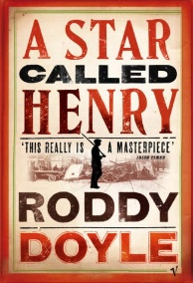  A Star Called Henry | Roddy Doyle | Historical Fiction, set in Dublin in 1916 | Born in the slums, raised on the streets, caught up in the fight for a free Ireland at the age of fourteen, Henry Smart is, indisputably, a survivor.
The Book Thief  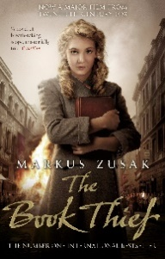 | Markus Zusac | Historical Fiction | A story about a Jewish girl who befriends a young man in hiding. Narrated by Death and set in Nazi Germany.
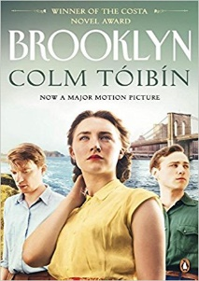  Brooklyn | Colm Toibin | Family/Relationships | The story of a young woman rural Ireland who leaves the world she’s known and moves to Brooklyn in the 1950s. Brooklyn is a story of identity, transformation and family ties.
Catcher in the Rye  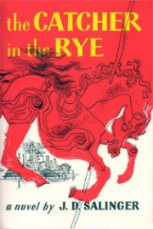 | J.D. Salinger | Family/Teenage Years/Relationships | Holden Caulfield is confused and alienated after being expelled from school so he takes a train to New York and wanders around aimlessly describing his encounters in his unique style.
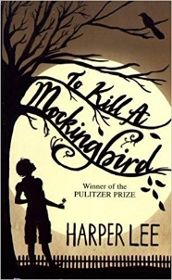  To Kill a Mockingbird | Harper Lee | Family/Relationships/Racial injustice | Eight-year old Scout’s father is a lawyer in a court case that splits a small community in the American Deep South.
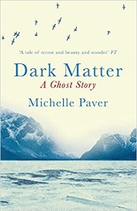  Dark Matter | Michelle Paver | Ghost Story | Tense and atmospheric tale of strange happenings on an Arctic expedition.
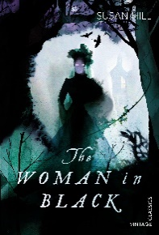  The Woman in Black | Susan Hill | Ghost/Gothic story- pastiche | A classic ghost story: the chilling tale of a menacing spirit haunting a small English town.
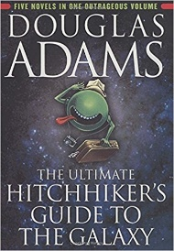  The Hitchhikers Guide to the Galaxy | Douglas Adams | Sci- Fiction/Humour | “Space is big. You won’t believe how vastly, hugely, mind-bogglingly big it is. I mean, you may think it’s a long way down the road to the chemist’s, but that’s just peanuts to space.”
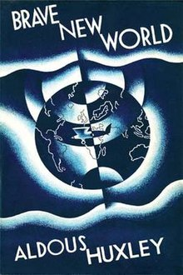  Brave New World | Aldous Huxley | Sci-Fiction | The ‘brave new world’ of the title is a place where there is no war or sadness, but where human beings are grown in laboratories and have their lives controlled.
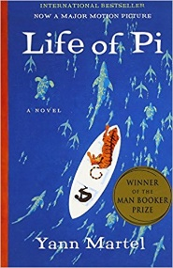  Life of Pi | Yann Martel | Adventure/ Magical realism | Fantasy adventure which describes how Pi survives aboard a raft with a tiger.
Touching the Void  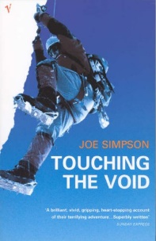 | Joe Simpson | Adventure/Survival story/ Non-fiction | An astonishing and gripping true story of a mountaineering incident.
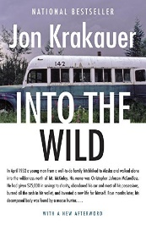  Into the Wild | John Krakow | Adventure/Non-fiction | A true and tragic story about a young man who ventured into Alaska to live independently in the wild.
The Hate You Give  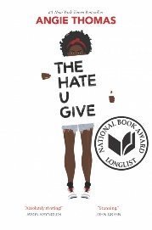 | Angie Thomas | Multicultural/ Racial Injustice | “As we continue to fight the battle against police brutality and systemic racism in America, THE HATE U GIVE serves as a much-needed literary ramrod. Absolutely riveting!” — Jason Reynolds
I am Malala  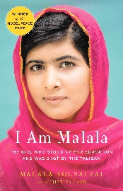 | Malala Yousafzai | Inspiring biography/  Multicultural | “The Taliban could take our pens and books, but they couldn’t stop our minds from thinking.”
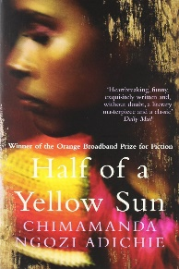  Half of a Yellow Sun | Chimamanda Ngozi Adichie | Multicultural | In 1960s Nigeria, Ugwu, a boy from a poor village, goes to work for Odenigbo, a radical university professor. When civil war begins their lives are forever changed.
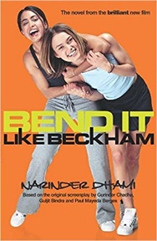  Bend it Like  Beckham | Narinder Dhami | Sports fiction/ Teenage years/Multicultural | Jess' parents want her to be a nice, conventional Indian girl. They pray she will settle down, study for law school, and learn to cook the perfect chapatti. But Jess has other plans. She wants to play soccer like her hero, David Beckham.
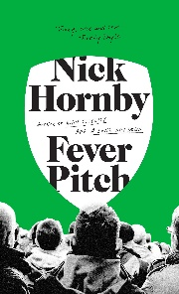  Fever Pitch | Nick Hornby | Sports fiction/ Teenage years | The number-one bestseller Nick Hornby explores childhood, adolescence and adulthood through the ups and downs of football in Fever Pitch.
Tangleweed and  Brine  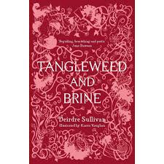 | Deidre Sullivan | Fairy-tales and feminism | Bewitched retellings of classic fairy-tales with brave and resilient heroines.
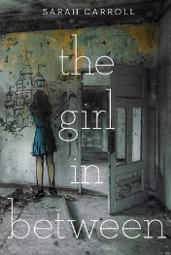  The Girl In Between | Laekan Zea Kemp | Relationships/ Teenage Years | Bryn Reyes is a real life sleeping beauty. Afflicted with Klein-Levin Syndrome, she suffers episodes of prolonged sleep that steal weeks, and sometimes even months, from her life. But unlike most KLS patients, she doesn’t spend each episode in a catatonic state or wake up with no recollection of the time she’s missed. Instead, Bryn spends half her life in an alternate reality made up of her memories.

- The Bees - Laline Paull
- Oryx and Crake - Margaret Atwood
- The Catcher in the Rye - J.D Salinger
- Noughts and Crosses - Malorie Blackman
- The Remains of the Day - Kazuo Ishiguro
- Cinder - Marissa Meyer
- Rebel Sisters - Marita Conlon McKenna
- If This Is A Man - Primo Levi
- One of Us is Lying - Karen M. McManus
- The Picture of Dorian Grey - Oscar Wilde
- Persuasion - Jane Austen
- Before I Die - Jenny Downham
- The Time Traveller’s Wife - Audrey Niffenegger
- The Outsiders - S.E Hinton
- City of Bones - Cassandra Clare
- The Life of Pi - Yann Martel
- Percy Jackson - Rick Riordan
- American Panda by Gloria Chao
- Down and Across by Arvin Ahmadi
- People Like Us by Dana Mele

