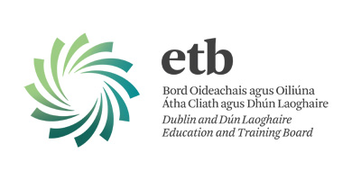
Kishoge Community College
Application Form
First Year September 2020

Student’s Details (PLEASE USE BLOCK CAPITALS)

Surname First Name

__________________________________________________ ___________________________________________________________

Home Address (where student lives) Parent’s Second Address (if relevant)

___________________________________________________ ___________________________________________________________

___________________________________________________ ___________________________________________________________

___________________________________________________ ___________________________________________________________

Home Telephone No: _______________________________ Home Email: ______________________________________________

Date of Birth: dd/mm/yyyy _______________________ Gender: Male ______ Female ______

Student’s P.P.S. Number: __________________________

Sibling attending Kishoge CC at same time YES/NO Sibling’s Name:________________________________________

If student is from outside Ireland when did his/her education in Ireland begin: _____________________________________

Parent(s)/Guardian(s) Details

Father’s First Name: _________________________________ Mother’s First Name: ________________________________________

Surname: ___________________________________________ Surname: ___________________________________________________

Occupation: _________________________________________ Occupation: _________________________________________________

Work No: ___________________________________________ Work No: ___________________________________________________

Mobile No: __________________________________________ Mobile No: __________________________________________________

Other Contact: _______________________Contact No: ___________________ Relationship to Student: ________________

Name of Present Primary School: ____________________________________________Principal: ______________________

Please turn over

Does your child require a place in the ASD unit? YES ______ NO _______

Are there any other circumstances it would be helpful to be aware of?

Acceptance of Code of Behaviour
It is a condition of enrolment that parents and students accept and agree to support the Code of Behaviour.
Please see Code of Positive Behaviour on school website. A paper copy is available upon request from the school office.

I accept and agree to support the Code of Behaviour:

Signature(s): Parent(s)____________________________________________

Please note that as a result of EU GDPR legislation enrolment to KCC is now a two-stage process: application and enrolment.

- All Application Forms received by closing date will be processed in accordance with Admissions Policy 2020.
- Offers of places and Enrolment Forms, requiring more detailed information, will be sent to successful applicants by 31st January 2019.
- Completed Enrolment Forms, must be returned within 28 days of issue or the offer of a place will be withdrawn and the place offered to a student on the waiting list.

Application Forms should be returned to:
Mr Niall Hare,  Principal,  Kishoge Community College  Ninth Lock Road,  Lucan,  Co. Dublin.  Phone 01-687 7482 | Please see Admissions Policy 2020 on www.kishogecc.ie
Closing date for receipt of Application Forms: 5.00pm, 30th November 2018
Offers of places will issue by 31st January 2019.

